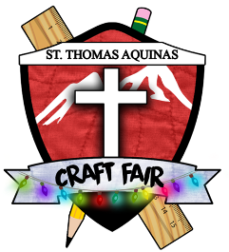
St. Thomas Aquinas Christmas Craft Fair
2019 Jury Form for New Artisans

Please complete the form below and submit it, along with photos of your art and/or crafts, by email to aquinascraftfair@gmail.com or by mail to the address below.
Christmas Craft Fair Coordinator
c/o St. Thomas Aquinas Regional High School
541 W. Keith Road
North Vancouver, V7M 1M5

Business Name:

Contact Name:

Address:

Telephone: Email:

Website:

Social Media:

Product description:

Price range: Are your products handcrafted in Canada?

Please list any craft fairs you’ve participated in over the last two years:

List any retail stores that carry your product(s):

How many years have you been involved in this craft?:

Do you require and have a Food Safe Certificate?:

Is there anything else you want the jury to know about your work?

Thank you for your application. We will be back in touch as soon as possible.

